[SELECT](http://localhost/phpmyadmin/url.php?url=https://dev.mysql.com/doc/refman/8.0/en/select.html" \t "mysql_doc) \* FROM `obat` WHERE 1;

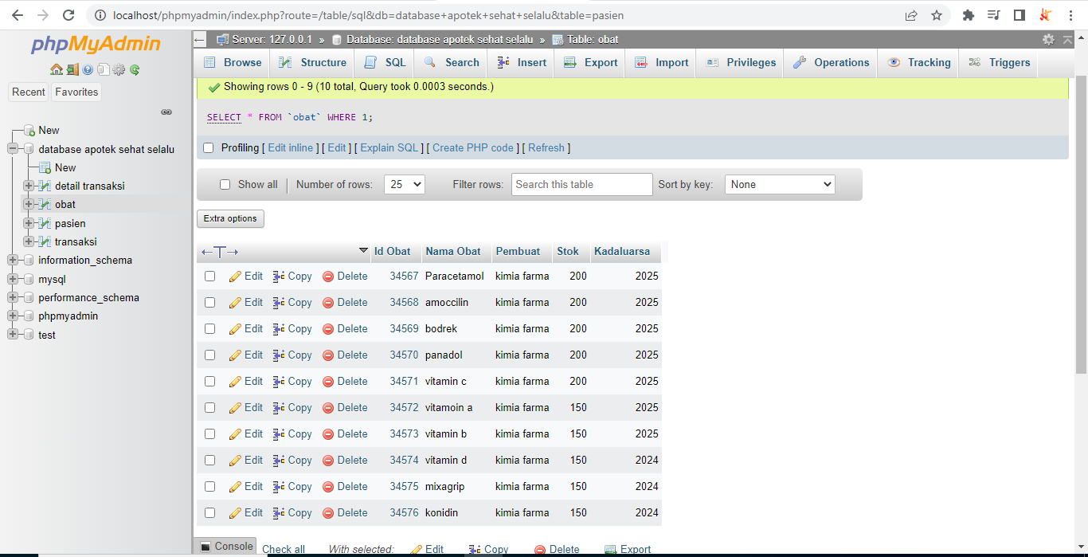

[SELECT](http://localhost/phpmyadmin/url.php?url=https://dev.mysql.com/doc/refman/8.0/en/select.html) \* FROM `obat`ORDER BY Kadaluarsa DESC;

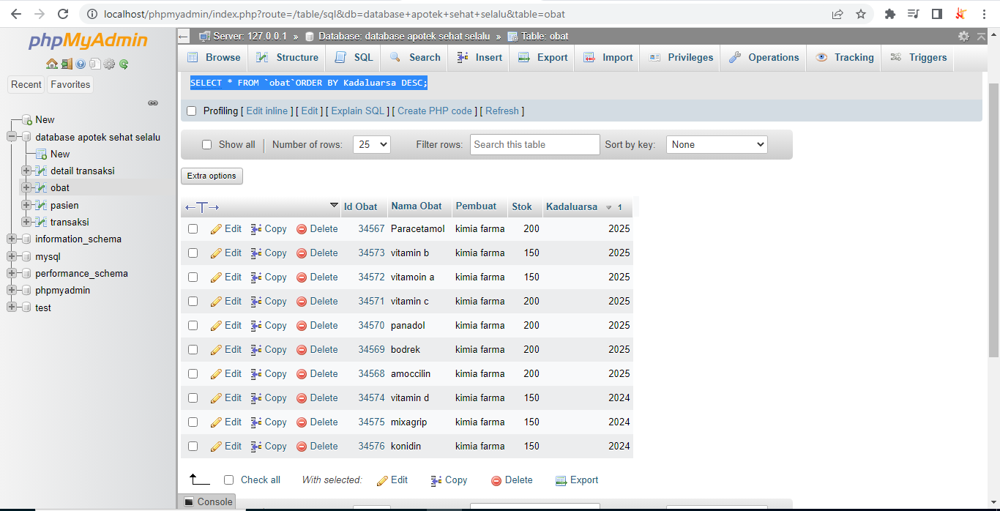

[SELECT](http://localhost/phpmyadmin/url.php?url=https://dev.mysql.com/doc/refman/8.0/en/select.html) \* FROM `obat` ORDER by Kadaluarsa ASC;

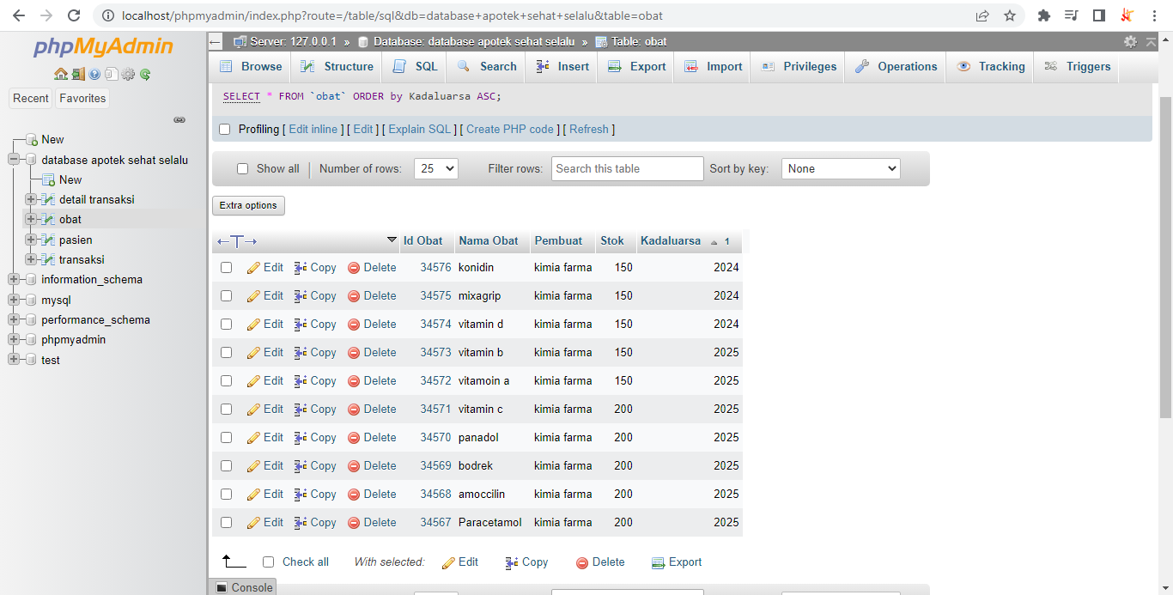

[SELECT](http://localhost/phpmyadmin/url.php?url=https://dev.mysql.com/doc/refman/8.0/en/select.html) \* FROM `obat` WHERE Stok [LIKE](http://localhost/phpmyadmin/url.php?url=https://dev.mysql.com/doc/refman/8.0/en/string-comparison-functions.html%23operator_like) '200';

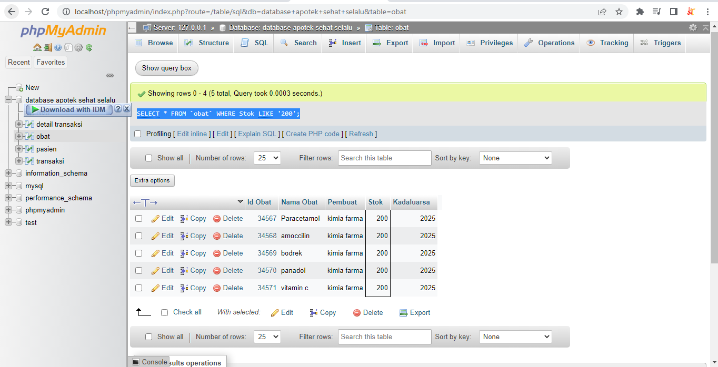

[SELECT](http://localhost/phpmyadmin/url.php?url=https://dev.mysql.com/doc/refman/8.0/en/select.html) \* FROM `obat` WHERE Stok [LIKE](http://localhost/phpmyadmin/url.php?url=https://dev.mysql.com/doc/refman/8.0/en/string-comparison-functions.html%23operator_like) '150';

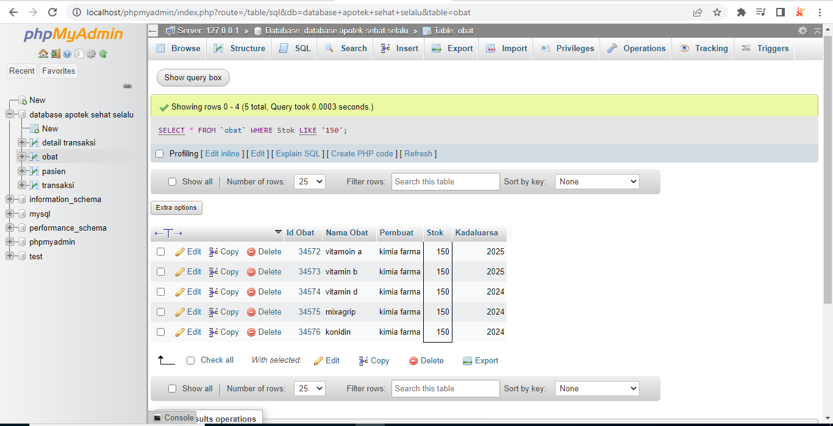

[SELECT](http://localhost/phpmyadmin/url.php?url=https://dev.mysql.com/doc/refman/8.0/en/select.html) \* FROM `detail transaksi` WHERE 1;

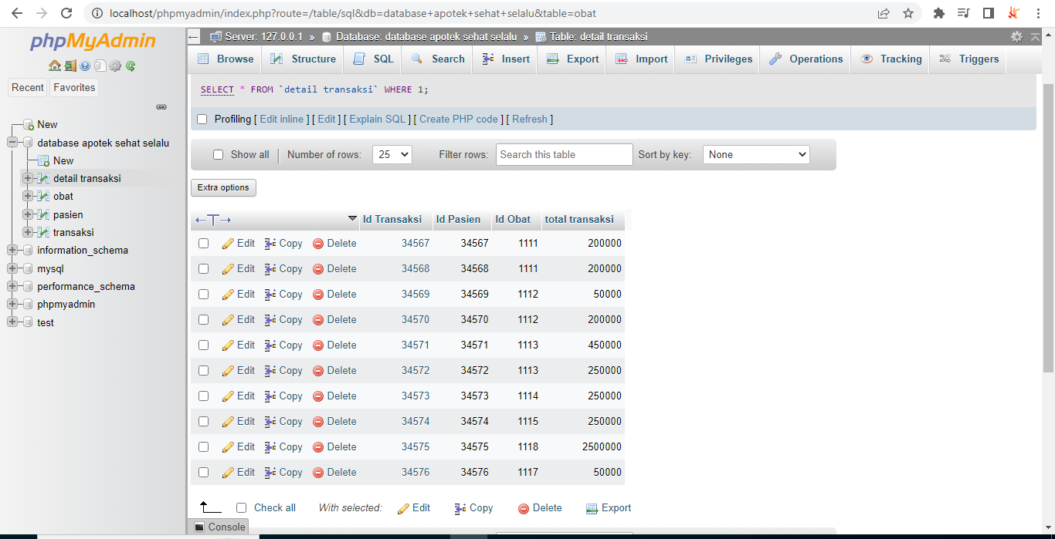

[SELECT](http://localhost/phpmyadmin/url.php?url=https://dev.mysql.com/doc/refman/8.0/en/select.html) \* FROM `pasien` WHERE 1;

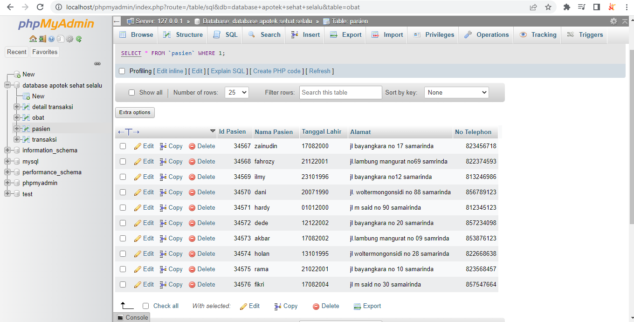

[SELECT](http://localhost/phpmyadmin/url.php?url=https://dev.mysql.com/doc/refman/8.0/en/select.html) \* FROM `transaksi` WHERE 1;

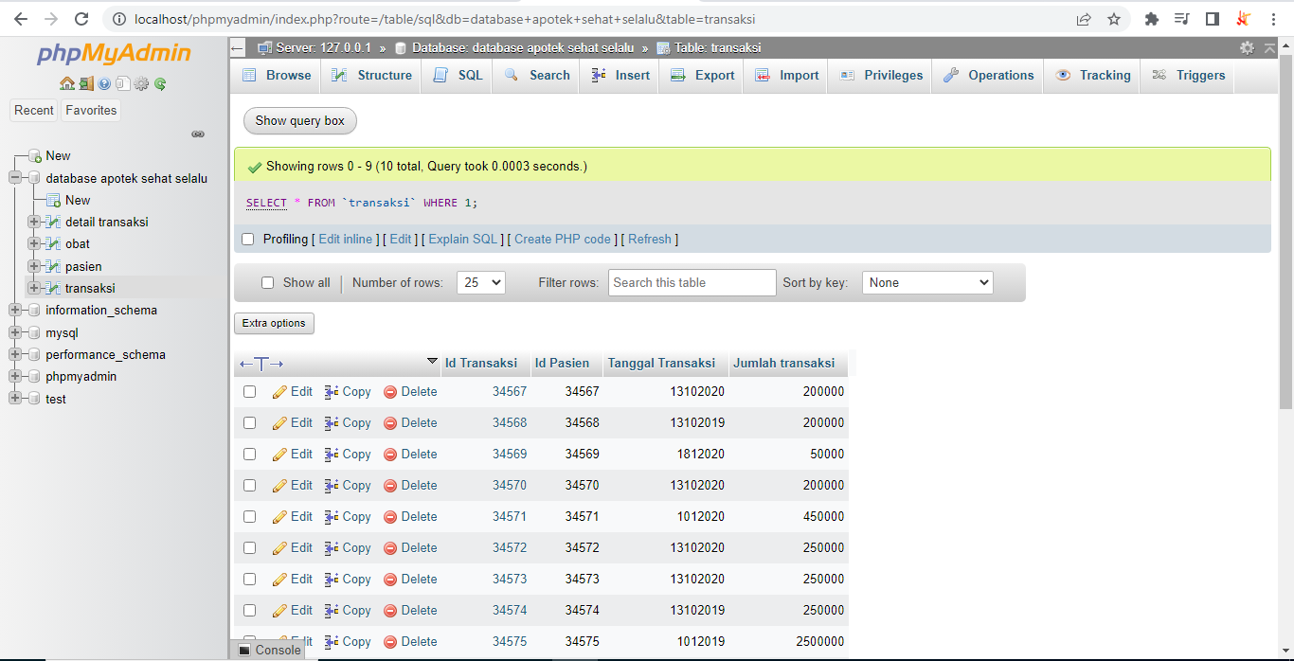

[SELECT](http://localhost/phpmyadmin/url.php?url=https://dev.mysql.com/doc/refman/8.0/en/select.html) \* FROM `obat` GROUP BY stok;

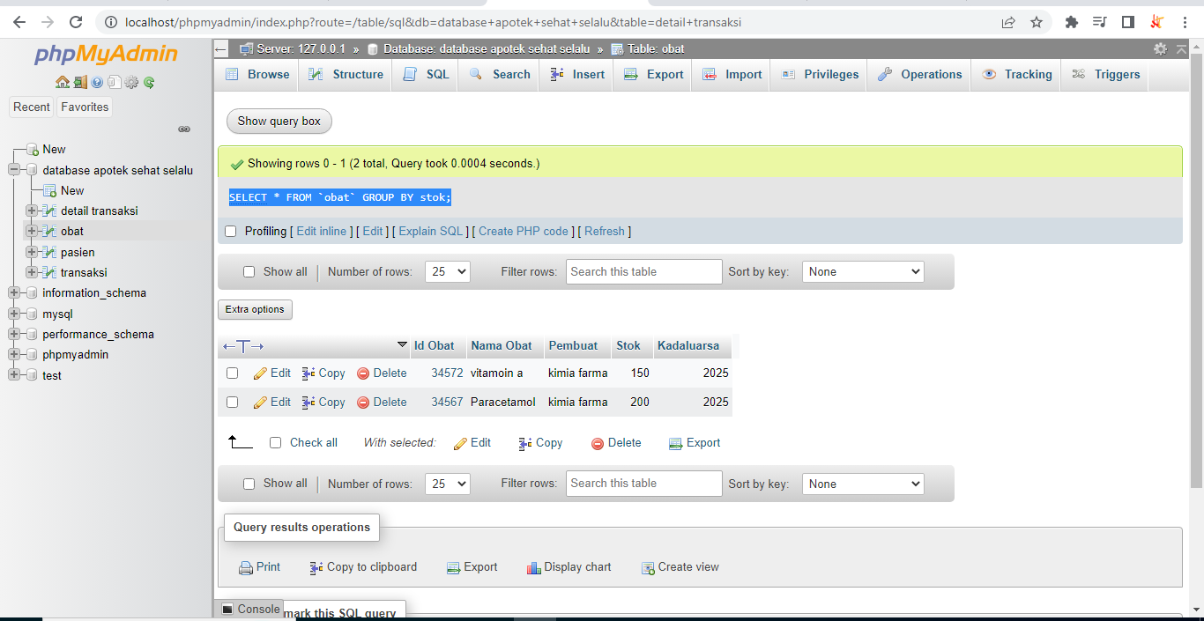

[SELECT](http://localhost/phpmyadmin/url.php?url=https://dev.mysql.com/doc/refman/8.0/en/select.html) \* FROM `obat` GROUP BY pembuat;

